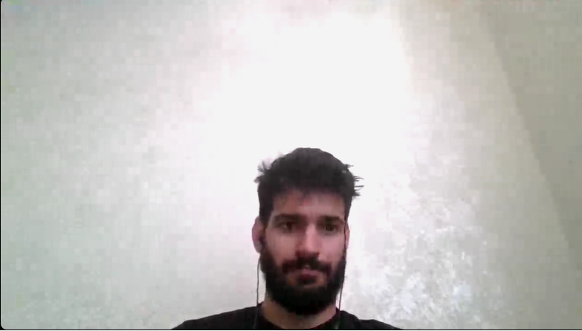

Esat arslan was born in hatay,samandağı at 1997. He completed his primary and middle school at same town he born. Then he continued to his high school at Jan ve Suphi anadolu lisesi which was a old French school. After high school, he won the physiotherapy department at Şişli Vocational School. After 2 years of study he decided this is not the job he wanted for himself to live on his life so drop out from the school and studied for a chance of computer science engineer. And he won computer science engineer department ad Adnan Menderes University. Currently he still studies. At the same time he was one of the finding members of Ege Universiy's Animal rights society. Also he is a licensed football and chess player.

Github User Name : esatarslan66